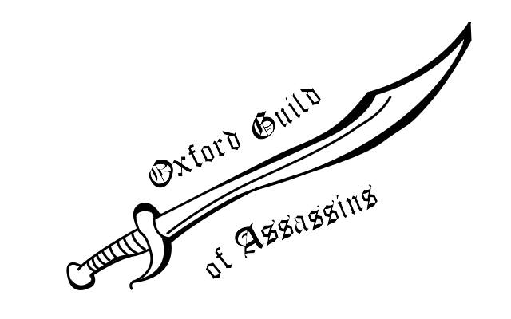
Term Card
Hilary 2014

Week | Day(s) | Event
2nd | Monday-Sunday | Individuals Game
3rd | tbc | Post Game Social, Cabal Elections
4th | One evening in the week | Varsity training/tactics sessions
4th | Saturday-Sunday | Varsity!
6th | Monday - Sunday | Teams Game
7th | Friday | Post Game Social
For more information contact the Guild Master, John Brazier (Merton).
The Oxford Guild of Assassins are not genuine hit-men, murderers or assassins. We can't help you with that. We might be able to cobble together a sternly worded letter on request – possibly in iambic pentameter – but honestly, you should probably get help before coming to us...
Fellow Inhumers,

This term brings two long games, including the most terrifying format: individuals, and several other important events:
- Varsity: Cambridge are coming here for the weekend of fourth week for our first ever varsity event! We’ll be needing competitors and people to host the Tabs. Team captain for this will likely be the winner of the 2nd week game: be prepared. (n.b. we are, sadly, not a blues sport)
- Due to two cabal members being horribly busy, we are moving elections up to 3rd week. Fancy trying your hand at Guildmaster? Want to be a mysterious minister without portfolio? Turn up and run.

[Type a quote from the document or the summary of an interesting point. You can position the text box anywhere in the document. Use the Drawing Tools tab to change the formatting of the pull quote text box.]
Future Events
Pirate Punting, Short Summer Games, Possible Doctor Who themed game, and any other events guild members wish to organise. If you wish to umpire (so much fun), get in touch with a cabal member.
Interested in Joining?

The Oxford Guild of Assassins is a lovely bunch of people who like to launch daring midnight raids, carry attack animals, write operatic kill reports and generally have a lot of fun! If a week of getting to know people because they’re standing outside your door with an attack otter sounds interesting (or you fancy trying some of our epic socials), sign up on the website:

www.oxfordassassinsguild.org.uk

then pidge the extortionate fee of £1 to Isobel Priest (St. John’s), for lifetime membership of Oxford’s most famous secret society.
And then possibly stock up on weaponry.

